## 

## **Experiment-8**

**Student Name:** Gauri Prabhakar **UID:** 18BCS6201

**Branch:** 18AITAIML-2 **Section/Group:** B

**Semester:** 7 **Date of Performance:** 10th November, 2021

**Subject Name:** Advanced Database Management Lab **Subject Code:** CSP - 434

# Aim/Overview of the practical:

To implement various operations on Packages and Triggers.

# Task to be done:

To implement various operations on Packages and Triggers.

# Steps to be followed:

**PACKAGE:**

**Creating a table STUDENTS and then returning it:**

# CREATE TABLE STUDENTS(Roll_No int, Name varchar(50), Age int);

# INSERT INTO STUDENTS VALUES(1,'Gauri',21);

# INSERT INTO STUDENTS VALUES(2,'Lilly',22);

# INSERT INTO STUDENTS VALUES(3,'Rose',18);

# SELECT * FROM STUDENTS;

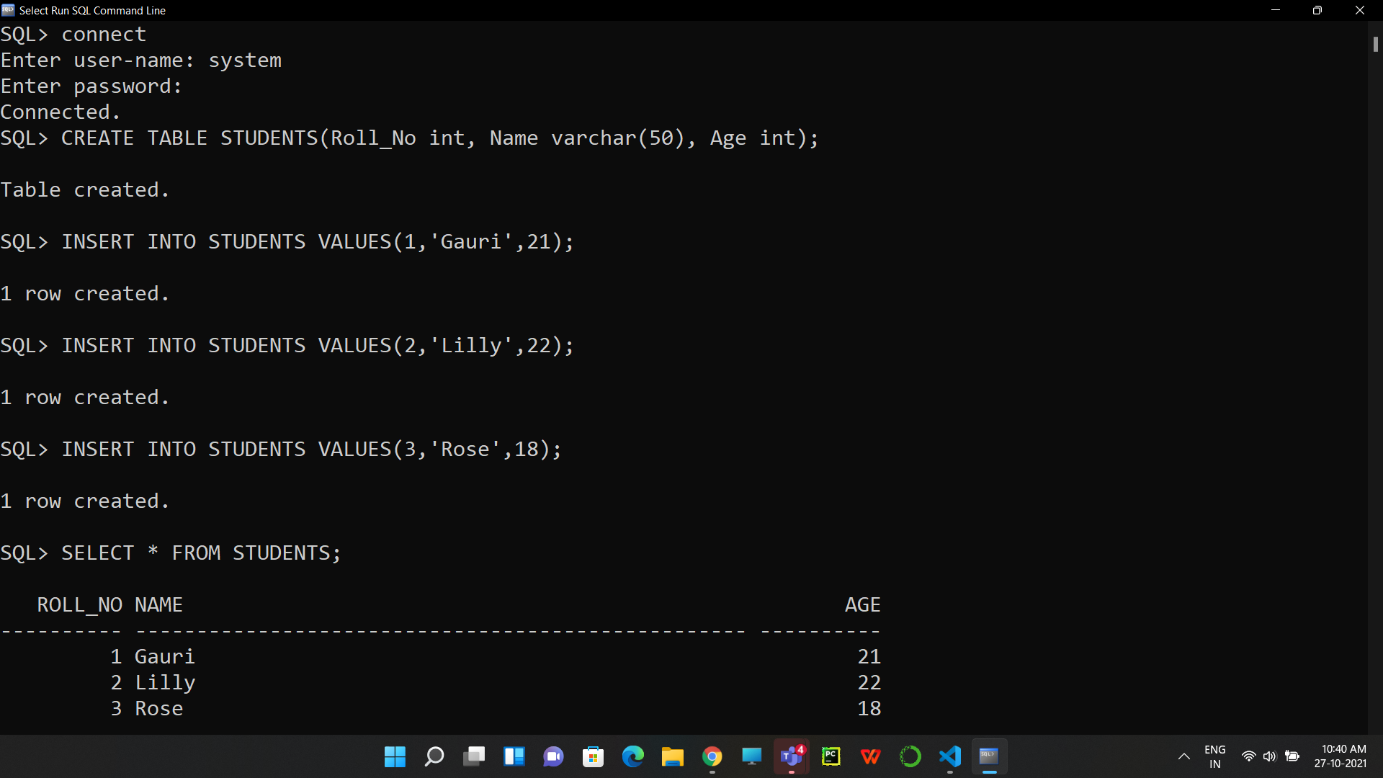

**Creating the package body and then defining it:**

1. SET SERVEROUTPUT ON;

CREATE PACKAGE STU_AGE AS

PROCEDURE FIND_AGE(S_ID STUDENTS.Roll_No%TYPE);

END STU_AGE;

/

CREATE OR REPLACE PACKAGE BODY STU_AGE AS

PROCEDURE FIND_AGE(S_ID STUDENTS.Roll_No%TYPE) IS

S_AGE STUDENTS.Age%TYPE;

BEGIN

SELECT Age INTO S_Age

FROM STUDENTS

WHERE Roll_No = S_ID;

DBMS_OUTPUT.PUT_LINE('Age: '|| S_AGE);

END FIND_AGE;

END STU_AGE;

/

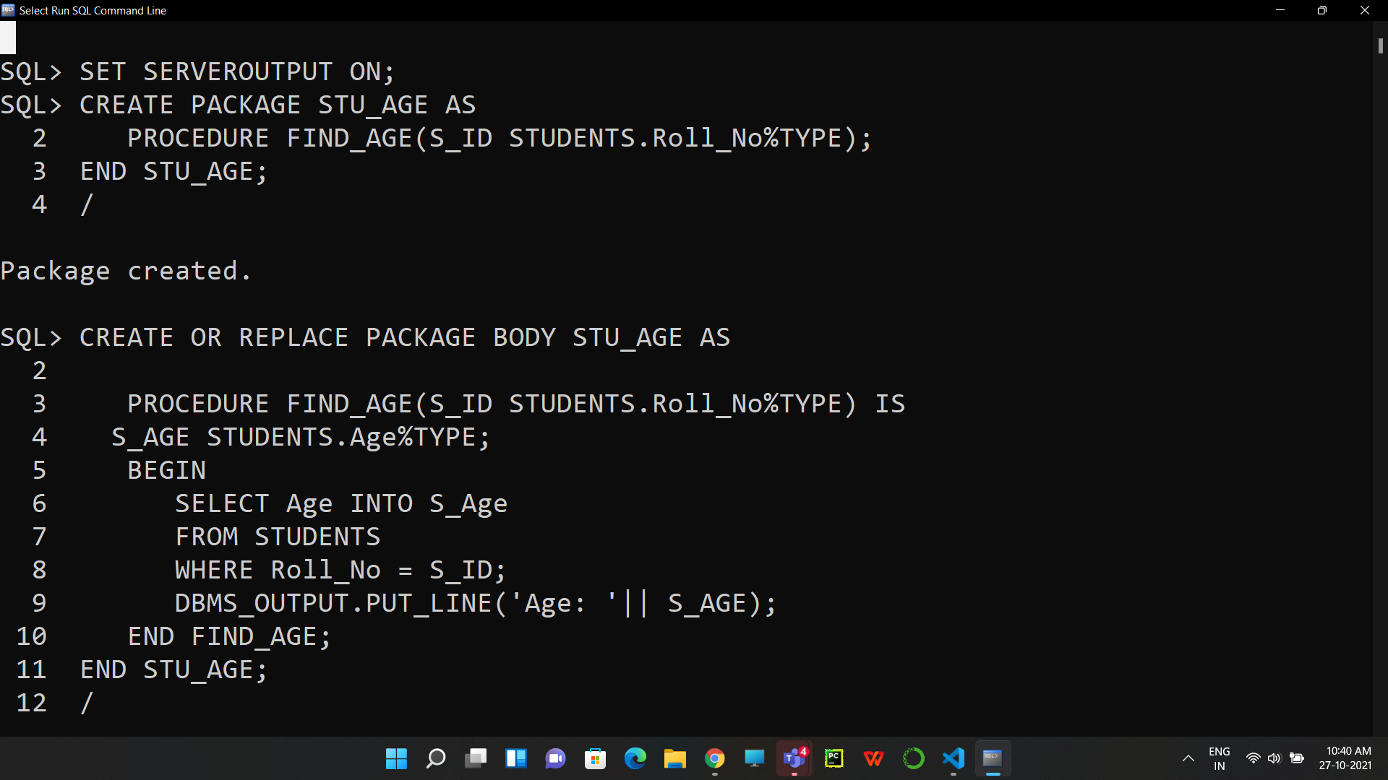

**Implementing the Package:**

1. DECLARE

SEARCH STUDENTS.Roll_No%TYPE := 1;

BEGIN

STU_AGE.FIND_AGE(SEARCH);

END;

/

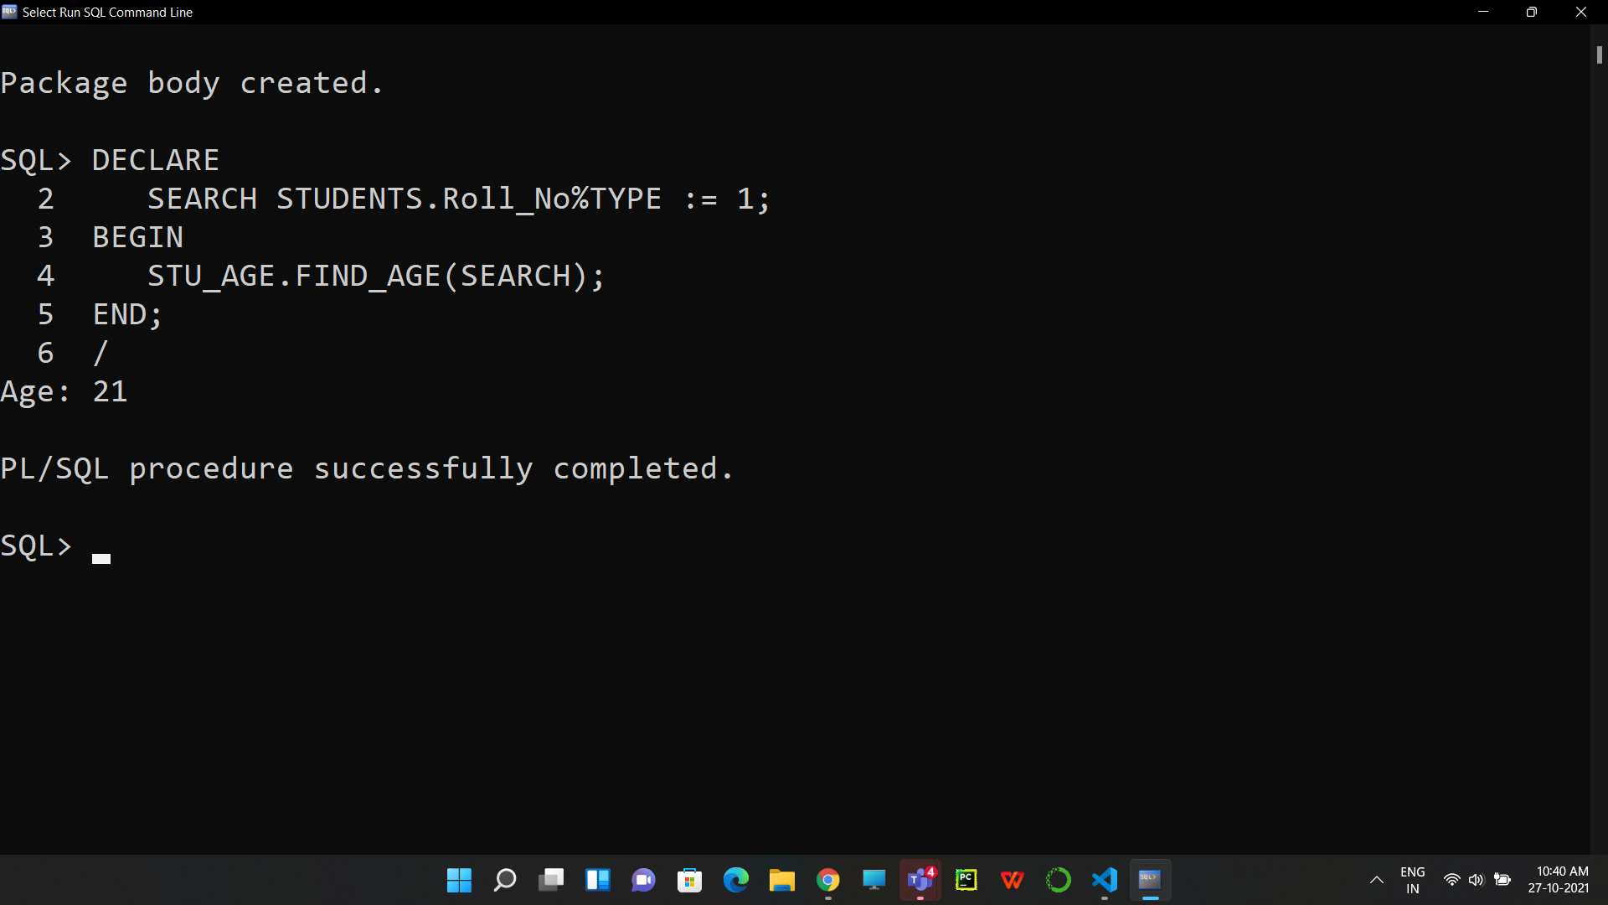

**TRIGGERS:**

**Returning the table MARKS and declaring the Trigger:**

1. SELECT * FROM MARKS;

SET SERVEROUTPUT ON;

CREATE OR REPLACE TRIGGER TRIG_MARKS

BEFORE UPDATE ON MARKS

FOR EACH ROW

WHEN (NEW.Marks>=0)

DECLARE

MARKS_DIFF NUMBER;

BEGIN

MARKS_DIFF:=:NEW.Marks-:OLD.Marks;

DBMS_OUTPUT.PUT_LINE('The OLD marks are:' || :OLD.Marks);

DBMS_OUTPUT.PUT_LINE('The NEW marks are:' || :NEW.Marks);

DBMS_OUTPUT.PUT_LINE('The MARKS DIFFERENCE is:' || MARKS_DIFF);

END;

/

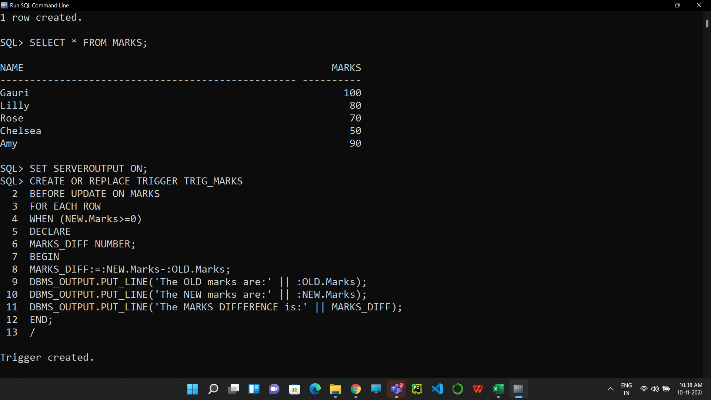

**Implementing the Trigger:**

1. UPDATE MARKS

SET Marks = 0

WHERE Name = 'Gauri';

SELECT * FROM MARKS;

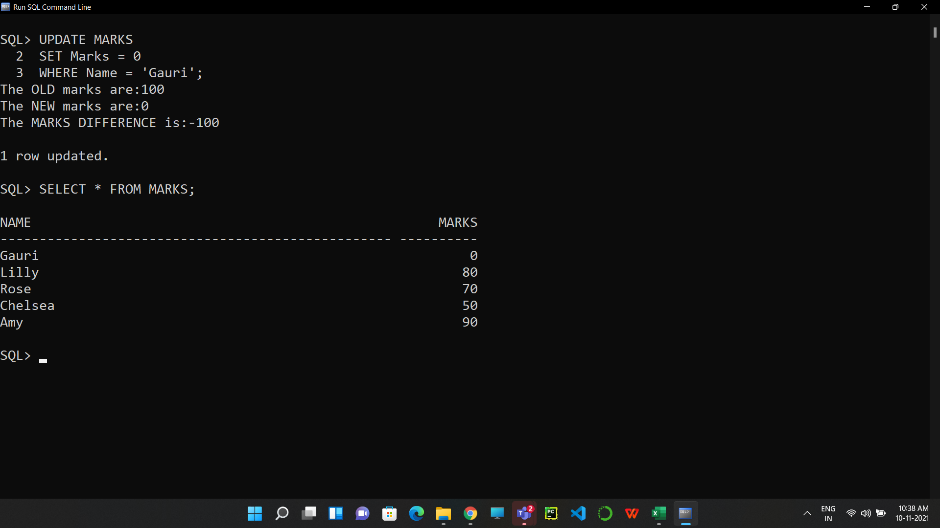

1. **Result/Output/Writing Summary:**

* Successfully implemented PACKAGES.
* Successfully implemented TRIGGERS.
* Successfully implemented operations on both PACKAGES and TRIGGERS.
* Successfully understood the functioning and importance of the above mentioned.

# Learning outcomes (What I have learnt):

* How to implement PACKAGES on SQL Command Line.
* How to implement TRIGGERS on SQL Command Line.
* How to implement TRIGGERS on a table.

**Evaluation Grid (To be created as per the SOP and Assessment guidelines by the faculty):**

|  |  |  |  |
| --- | --- | --- | --- |
| Sr. No. | Parameters | Marks Obtained | Maximum Marks |
| 1. |  |  |  |
| 2. |  |  |  |
| 3. |  |  |  |